ACTION post - Manual Unit Testing

**For these tests we are temporarily modifying our testRunner.js to insert tps_created, tps_posted, tps_expires dates that test the limits of the contract.**

**PASSED** - +180 second for tps_expires, max allowed

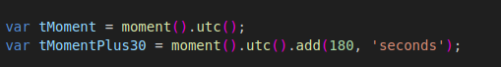

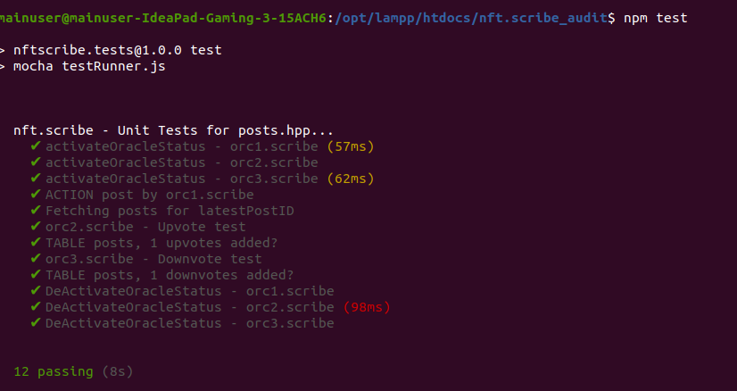

**PASSED** - +1 second for tps_expires, test, should work

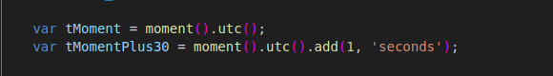

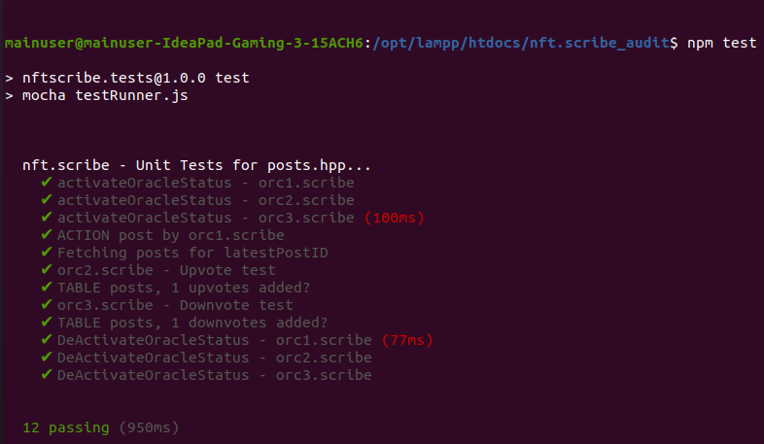

Requires you speed up the execution of testing to be fast, but still works when you do.

**PASSED** - +0 second for tps_expires, min test, should fail / delete

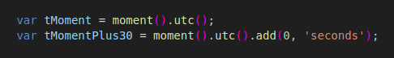

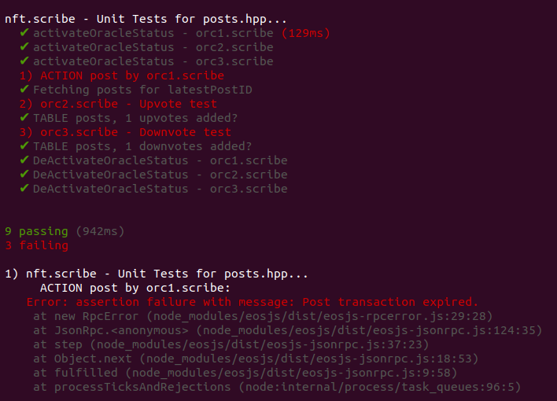

**PASSED** - -1 second for tps_expires, should fail

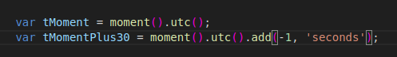

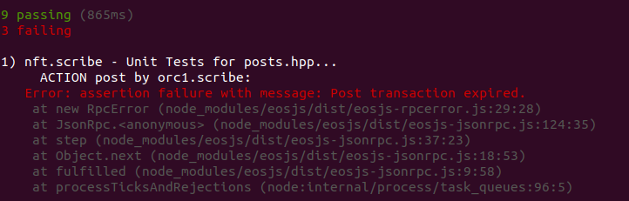

**PASSED** - +181 second for tps_expires, should fail

